Mapa
The Polish word for map is ‘mapa’. We looked at where Poland was in Europe. Then we labelled all of the countries we have heard of, in Europe.

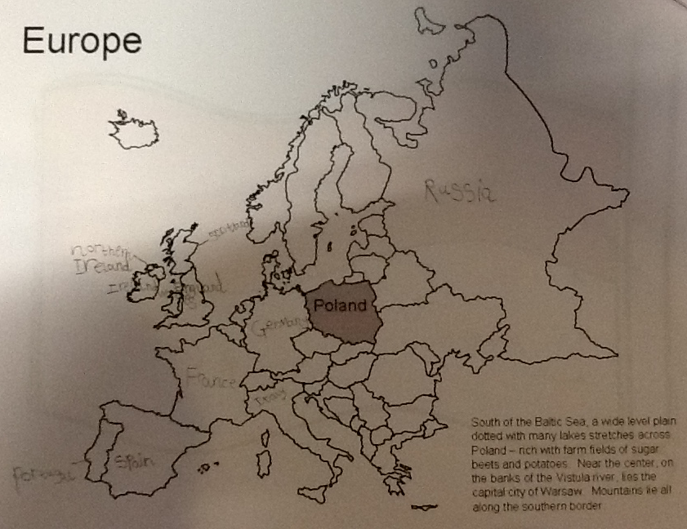

Warsaw

Warsaw is the capital city of Poland. We wrote a few of our favourite facts about it on a map of Poland.



