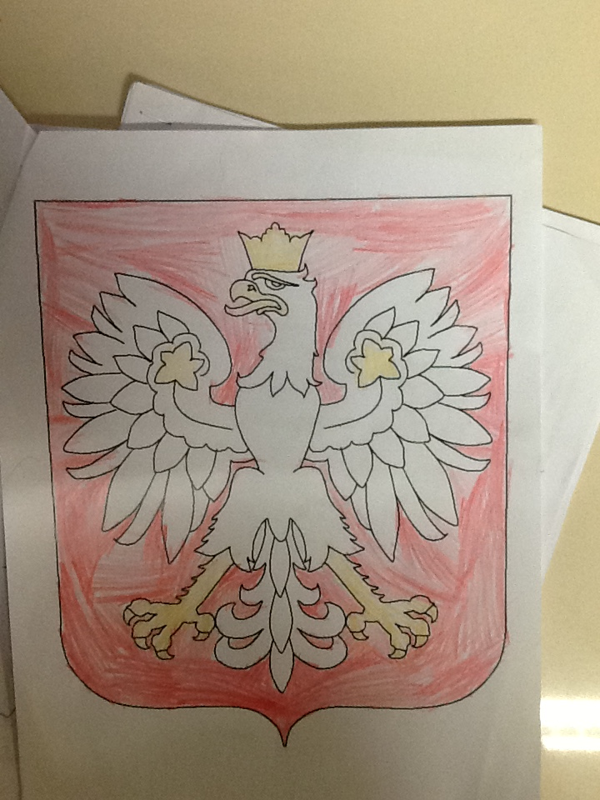
The National Emblem of Polska

We watched a YouTube video that told us all about the symbol of Poland. It is the White-Tailed Eagle. We also heard about how Poland’s first leader, Lech, saw a white eagle’s nest and saw the white eagle fly with the sun’s golden rays touching the edges of the feathers. Lech decided that was where he wanted to live. That was the beginning of Poland.

