
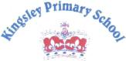
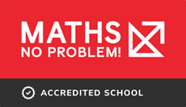
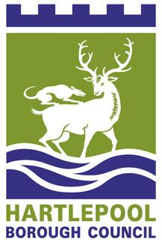
KINGSLEY PRIMARY SCHOOL
TAYBROOKE AVENUE
HARTLEPOOL
Telephone: 01429 273102
Headteacher: Mrs A. J. Darby
TAYBROOKE AVENUE
HARTLEPOOL


www.kingsleyprimary.com
admin@kingsleyschool.org.uk

September, 2024
Dear Y4 Parent/Carer,
The Multiplication Tables Check (MTC) for year 4 children will take place between Monday 2nd June and Friday 13th June 2025.

What is the Multiplication Tables Check?

- The checks consist of 25 times tables questions. The questions will only be multiplication and they will go up to 12×12. The questions don’t require problem solving so there’s nothing to trip them up.
- There will be 6 seconds to answer each question.
- The check will be taken online during school time.
- Teachers will be able to apply for some children to be able to pause between questions.
Why do the children need to take this test?

All year 4 pupils in England will take the check. The Government made the check compulsory in 2022. They say:

The purpose of the MTC is to determine whether pupils can recall their times tables fluently, which is essential for future success in mathematics. It will help schools to identify pupils who have not yet mastered their times tables, so that additional support can be provided.

Why are times tables so important?
Having rapid recall of times tables makes other areas of maths much easier. Fractions is the most obvious area where learning times tables well is essential. Also, every multiplication and division method requires speed and instant recall of times tables. Then, when they move to secondary school, the needs become even greater.
Furthermore, having the tables secure frees up their working memory for newer, more challenging tasks at hand. Therefore, learning them now sets children up for a more successful maths throughout their school life.

Support in school

Children are working incredibly hard in school to improve and secure times-tables recall facts. Our M-NP! lessons help children to master their understanding and we also practise recall daily. This support will continue throughout the year.

PTO

How can you help them improve their recall times?
There are lots of ways to learn times tables, but here are a few suggestions to get you started:

- Make sure they play frequently in Garage mode on Times Tables Rocks Stars - the Garage game mode is very clever and will adjust the questions your child is asked, ensuring they are always working on the facts they need to improve.

- Sing times tables songs - there are hundreds available (on YouTube)! Put them on whenever you have a few spare minutes.

- Chanting the old-fashioned way- rehearse the tables forwards and backwards, gradually increasing in speed.

- Write out the tables – this can be in the form of a simple list or you could also be a bit more fun. Being creative will make writing and learning the tables more enjoyable:
- Get them to test you on the facts and get them wrong on purpose and see if they correct you!
- Treasure Hunt: Hide the facts around the house and give them the answers. Can they find them in record time?

As always, we thank you for your continued support. We appreciate that many children have other commitments outside of school but…
a little bit of practice often will make a huge difference…
…to your child’s rapid recall.

If you have any questions (or require any further advice), please see a member of the year 4 team.

Thank you!

Kingsley Year 4 and Maths teams.

