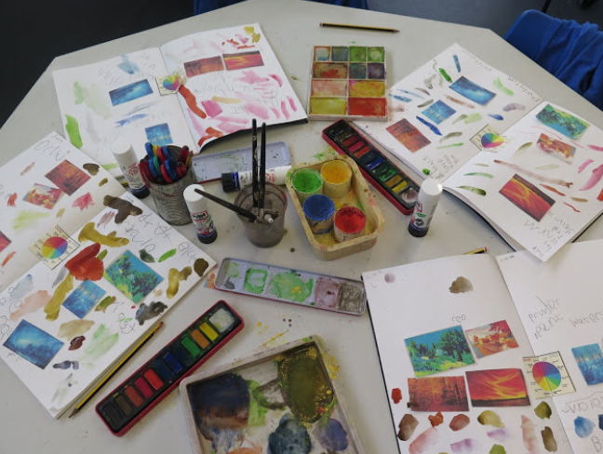
Sketchbooks

Guidance and expectations
2023

Sketchbooks are a useful way of demonstrating progression of art skills in all forms from Reception to Year 6 in an easy-to-capture way, as well as clearly highlighting the long term plan you are following as a school.

Introduction
Sketchbooks are a vital example of evidence in Art and should show the artistic journey of a child. A sketchbook should be a place where children can record their ideas, inspirations and a place to practice and refine skills. These books are a place for children to experiment with a range of ideas and materials as well as allowing children to annotate their own images. Improving and changing our use of sketchbooks will both improve the quality and creativity of the art produced and prepare the children for secondary school.
Sketchbooks, not exercise books
Sketchbooks are different from other books used in school and should be treated as such.
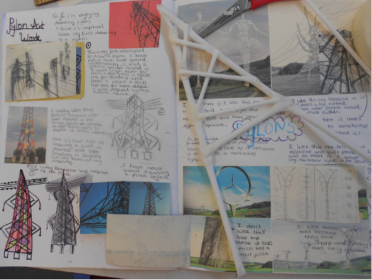
In these books we should see:
- Creativity
- Doodles
- Trial and error
- Mistakes
- Colour
- Fabric
- Found objects
- So much more…
Sketchbooks are a visual diary of ideas and experimentation. These can be very personal to the children and we should allow the children to add their own touches to their sketchbooks.

Expectations
Sketchbooks will be treated very differently to the other books in school due to their different purpose.
Appearance
Sketchbooks should be exciting to look at, touch and feel, and are central to good practice.
Sketchbooks will have a range of sketches, paintings, prints, charcoals etc. therefore their appearance will reflect their creative nature. They can have a range of materials in and do not have to be pristine. They should be a ‘visual diary’ of a child’s ideas, experimentation and evaluation. Children can annotate their work and label experiments for their own learning and record keeping.

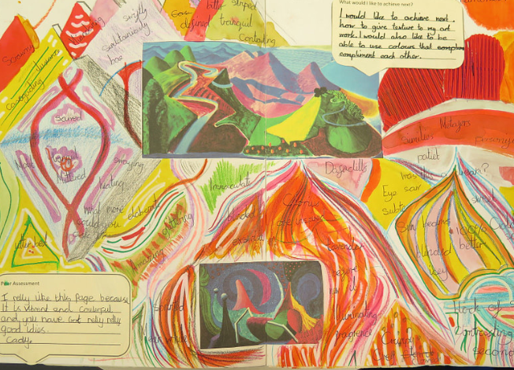

Marking
Marking and feedback should be in response to the creative activities of drawing, putting down ideas and carrying out design work. As the work is predominantly visual, there are no right or wrong answers. In this subject, children do learn from mistakes and those should be valued as part of the working process.
Therefore, most feedback will be given as verbal feedback which will be happening during the lesson. Objectives and skills will be marked on progression overview that will be stuck in sketchbooks at the start of each academic year. No artwork will be written on to respect the child’s thinking space and creative process.

