
Exciting New
Reading Books!

At Kingsley, one of our primary aims is to develop fluent, confident readers who value and enjoy books. In order to do this, we believe children need to access a range of exciting texts from the very start of their education.
This year, we are very happy to launch a new reading book scheme from Reception to Year 6. These books are matched to the phonics knowledge of our developing readers and provide challenging texts for readers that are more confident. We hope that this scheme allows children to access a range of texts across the entire breadth of the curriculum.
Changes to the current scheme
Previously, children read between 1 and 5 times per week in school and their book was changed each time. However, research suggests that reading a text more than once cements understanding, helps foster a love of reading and improves fluency.
From Monday 27th September 2021, your child will receive a book that is matched to their level with text they can read independently. Children have all been assessed individually to ensure this. The new scheme also focuses on vocabulary and what words mean, therefore your child will keep their book all week to explore it thoroughly.
Your child will take their book home on a Monday and it is expected that it is brought to school each day. Children who return their reading book will be offered a ‘treasure chest’ of books to choose from to enjoy reading at home over the weekends. Some of these texts will require a family member to read with your child, especially in EYFS and Key Stage 1. If you have any questions, please speak to the class teacher or a member of the leadership team.
It is crucial that children return their book each day!
Your child will also have a reading log. It is expected that at least once per week, a family member will listen to your child read and record this in their log (please see attached sheet).
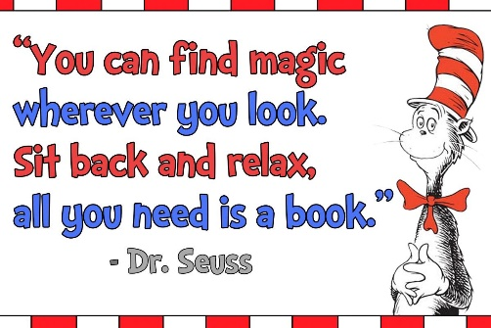
On a Thursday, all reading logs will be checked, and any children who have not read will be given a reminder slip to take home.
In order to demonstrate your support, we ask that you read, sign and return the attached ‘reading promise’ to your child’s class teacher as soon as possible.
Thank you for your support!
The Literacy Team

