Reading with your child in Reception and Year One
The book your child will bring home has been matched to their current phonics level. That means the sounds they are working on in school will be found in the books they bring home each week. These will be split into ‘phases’ from phase 1 to phase 5.
Our phase 1 books are picture books and inside the cover you will find lots of ways to explore a book without words including questions to ask and talking points.
Our phase 2 to 5 books will contain words, which your children should be able to read independently. Before you begin reading, you will find a ‘quick check’ in the front cover. It is important to work through this with your child before beginning the book. If you feel your child is struggling with this then please consult the class teacher.
While your child is reading, it is important to ask questions to check understanding (comprehension) of the text and vocabulary. Examples of these can be found in the back of the book.
We ask that at least once a week you write in your child’s reading log to ensure consistency between home and school. Some examples of these comments may be:
- _____ read well today. They were able to answer questions to show they understood the book.
- _____ tried hard today, but found a few words tricky. They needed help with ….
- Lovely reading today! _____ was able to read the words on sight and make predictions about what could happen next.
- _____ read this book confidently. They answered questions and could talk about new vocabulary.
On a Thursday, all reading logs will be checked, and any children who have not read will be given a reminder slip to take home. Each Friday, children who have returned their book will be given a sharing book to bring home to read with you!
In order to demonstrate your support, we ask that you read, sign and return the attached ‘reading promise’ to your child’s class teacher as soon as possible.

Thank you,
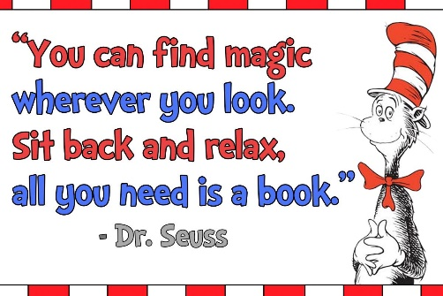
The Literacy Team



