Reading with your child in Key Stage Two
Your child will bring home a reading book every Monday matched to their current reading ability level. This is based on fluency (being able to read words on sight and with good pace) and comprehension (understanding of the book). They will be expected to share their book with an adult or read independently at home at least once per week and this should be recorded in their reading log.
Ideally, you should listen to your child read for 15 - 20 minutes per session but anything is better than nothing.
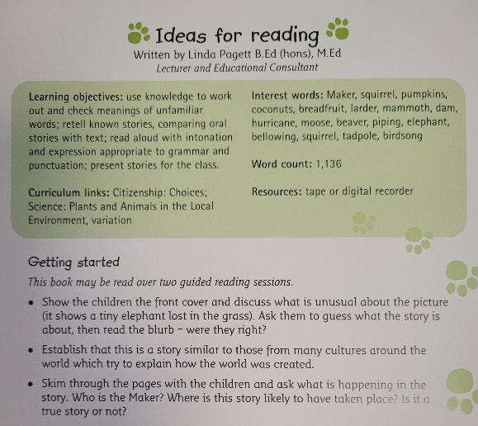 | You can use prompts at the back of the book to help you discuss events during the reading or after the reading.  You can also check your child’s understanding of vocabulary as they read.  At the end of your reading, ask your child to make a prediction about what they think will happen next. This is a good way to keep your child engaged and check they have understood the text so far.
Here are some examples of reading comments you may wish to write in their reading log:
- _______ read fluently and with lots of expression for the characters.
- We talked about the meaning of spiralled, interminable and extravagant.
- _____used clues from the text to talk about the type of character Charlie was.
- _____ has enjoyed this book so far. We have made predictions based on evidence in the text.
- We discovered some interesting facts about __________ this week and explored the layout.
Reading logs will be checked on a Thursday and a reminder slip sent to those who have not read at home. All books will then be collected on a Friday and children who have returned them will be allowed to select a choice book for the weekend.
In order to demonstrate your support, we ask that you read, sign and return the attached ‘reading promise’ to your child’s class teacher as soon as possible.
Should you require any further guidance, please speak to your child’s class teacher or a member of the leadership team.
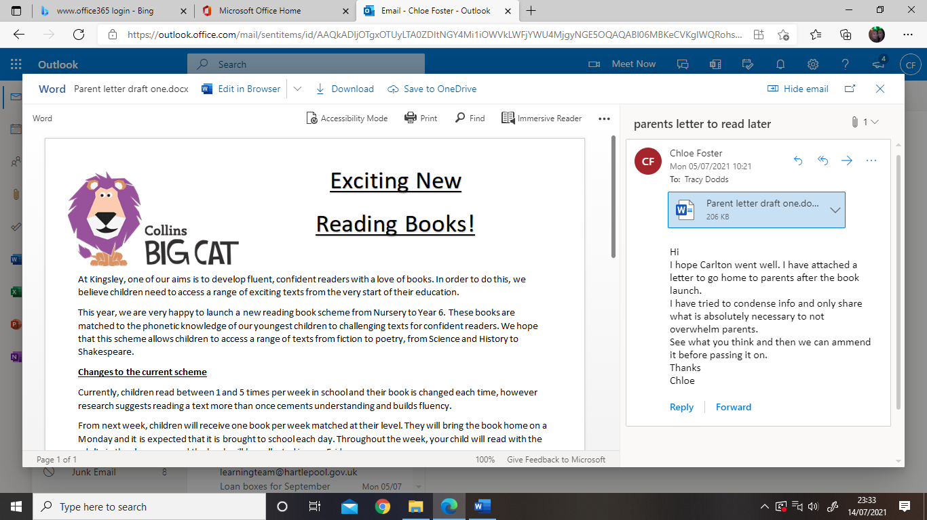

Thank you,
The Literacy Team

