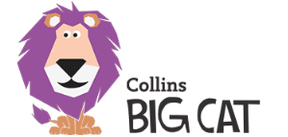

Our Reading Promise
Please read the attached information carefully about our new reading scheme before signing.
- I promise that my child _____________will read at home at least once per week.
- I promise that my child will return their book to school each day.
Signed _______________________________

